**Log Insights Queries**

* Extracting fields from message using parse

fields @timestamp, @message

| parse @message "* - - [*] \"* * \"" as clientip, generated_time, request, other

| sort @timestamp desc

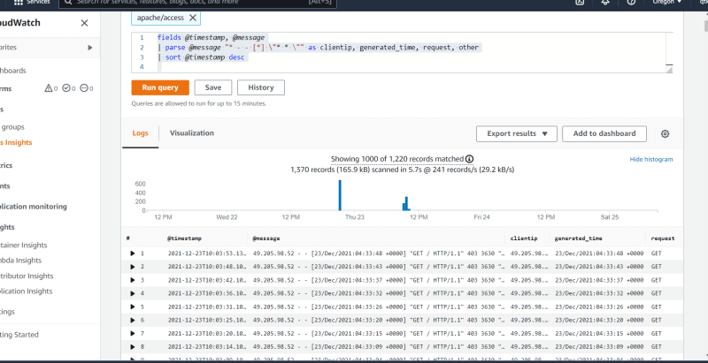

* Further fields

fields @timestamp, @message

| parse @message "* - - [*] \"* / *\" * * * " as clientip, generated_time, request, http, statuscode, size, other

| sort @timestamp desc

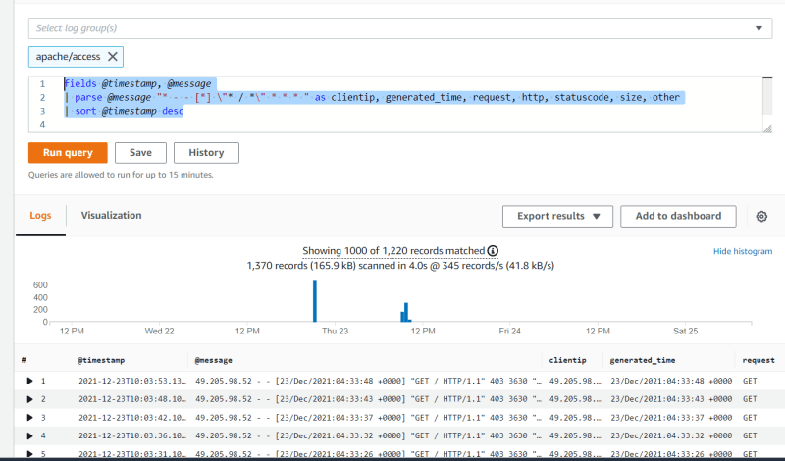  
* In the log analytics we can use some functions  
* Lets get started from stats  
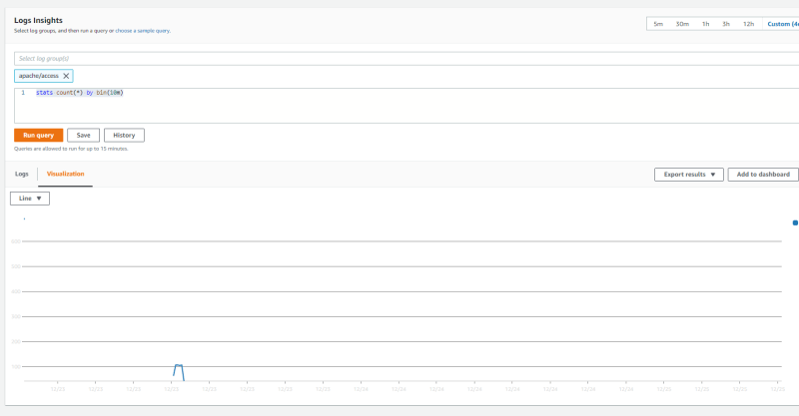  
* The above query returns a time series data  
* Query to show only valid ip addresses responses

fields @timestamp, @message

| parse @message "* - - [*] \"* / *\" * * * " as clientip, generated_time, request, http, statuscode, size, other

| filter isValidIp('clientip')

| display clientip, statuscode

| sort @timestamp desc

* Pricing of Cloud Watch Alarms <https://aws.amazon.com/cloudwatch/pricing/>